- Synchronization

- It is a modifier only applicable for methods (both static and instance methods) and blocks but not for class and variables.
- If multiple threads are trying to operate simultaneously on the same java objects, then there may be chance of data inconsistency problem.

To overcome this, we should go synchronized keyword:
- If a method or block declared as synchronized, then at a time only one thread is allowed to execute that method or block on the given object. So that data inconsistency problem will be resolved.
Advantage:
- We can resolve data inconsistency problem
Disadvantage:
- Until completing first thread, second thread has to wait so the waiting time of thread increases and creates performance problem.
- For above disadvantage, we have concurrent package in java.util

How Synchronization works:
Internally Synchronization is implemented with lock (unique per object) concept available in Object class.
Every object in java has a unique lock. Whenever we are using synchronized keyword, then only lock concept will come into the picture.

If a thread wants to execute a synchronized method or block on the given object, first it has to get the lock of that object.
Once the thread got the lock, then it is allowed to execute any synchronized method on that object. Once method execution is completed, automatically thread releases the lock.

Acquiring and releasing lock are internally takes care by JVM.
When requesting the synchronized method or block on object, thread get the lock automatically and releases it when method exception completed.

- When one thread gets the lock, then other thread has to wait until the lock release.
- When one thread executing one synchronized method on a object, it get the lock and remaining threads are not allowed to execute any other synchronized block on that object. Because to execute synchronized block it need lock but it already acquired by another thread.

Example:
Class X{
Synchronized m1(){}
Synchronized m2(){}
m3(){}
}
Consider t1, t2, t3, t4 threads. Consider t1 acquired the lock(X) and executing synchronized m1(). In mean time, t2 and t3 came to execute synchronized m1(). In order to execute the synchronized method on X object, t2 and t3 needs the lock of X but it is already acquired by t1. Hence t2 and t3 won’t get the chance to execute synchronized m1() until t1 complete the m1(). So t2 and t3 go to waiting state. In mean while, t4 came to execute non synchronized m2() and it can execute without need of lock since it is trying to execute non synchronized m2().

Question:
Since t1 acquired the lock of X object and executing the synchronized m1(), then how t4 executes the non synchronized m2()?
- There are 2 areas synchronized and non- synchronized area in every object. To execute synchronized area, the thread need lock but not for non- synchronized area. Hence t4 can execute the non- synchronized m2() in which we don’t write code for changing object states and we do only read operation here. But in synchronized area only, we have to write code to change the object state where we perform update, insert and delete. So the synchronized area can be accessed by only one thread at a time and non- synchronized area can be accessed by any no of threads simultaneously.

While a thread is executing synchronized method on given object, the remaining threads are not allowed to execute any synchronized methods simultaneously on the same object. But remaining threads are allowed to execute non synchronized methods simultaneously.

Synchronized area:
Wherever we are performing update/add/delete operation which changes the state of object, then it should be in synchronized. So that threads are accessed by sequentially. This is called synchronized area.
Example: Booking tickets which performs update operation

Non-synchronized area:
Wherever object state won’t be changed like read operation, and then it is called non-synchronized area. Hence many threads can be accessed directly.
Example: Checking ticket availability which performs read operation only

Example: In below program, synchronization is not required, since we created only one thread. Eventhough if remove the synchronized keyword for wish method, it works regularly.
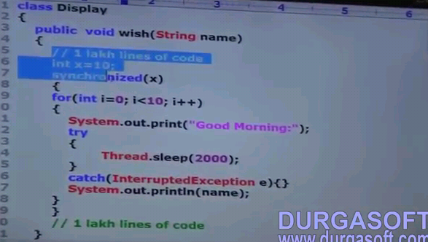
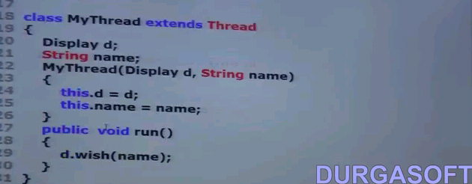


For above program, if we create multiple threads and wish() is not synchronized one, then we get data inconsistency problem that is we don’t get the consistent output. In order to get the consistent output, make the wish() as synchronized one and execute our multi threads. Below is the main program for above class to create multi threads.
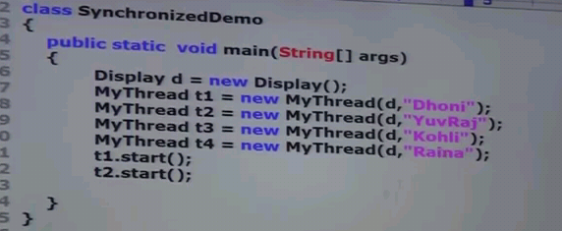

Synchronization Required:
If multiple threads try to execute on same object, then synchronization is required.

Two types of Lock:
- Object level lock
- Class level lock

Static synchronization: (Class level lock)
- Every class in java has unique lock which is nothing but class level lock.
- For every class, one Class class object is created internally by jvm. That object lock is called class level object. So class level object is also internally an object level object.

When a thread required class level object?
If a thread wants to execute static synchronized method, then it need class level object.
Once thread got class level lock, then it is allowed to execute any static synchronized methods of that class. Once method exception completes, the thread releases that lock.

When a thread executes static synchronized method, then remaining threads are not allowed to execute static synchronized methods of that class simultaneously. They have to wait until the lock releases on that class to execute static synchronized methods. But remaining threads can execute normal static methods, synchronized instance methods, normal instance methods.

Class x {
static synchronized m1()
static synchronized m2()
static m3()
synchronized m4()
synchronized m5()
m6()
}

Synchronized block:
If very few lines of the method requires synchronization, then declare those lines in synchronized block instead declaring the whole method as synchronized which improves performance.

Declaring the synchronized block follows in below three ways:
1) To get lock of current object:
synchronized(this){
}
If a thread got lock of current object then only it is allowed to execute above area.

2) To get lock of particular object:
synchronized(b){
}
If a thread got lock of particular object 'b' then only it is allowed to execute above area.

3) To get lock of class level object:
synchronized(Display.class){
}
If a thread got lock of Display class, then only it is allowed to execute above area.

- Lock is applicable for class and object level only but not primitive types (throws unexpected type)

Questions:
Synchronized keyword?
- It is a modifier applicable for methods and blocks. Not for variables and classes.

Advantage of Synchronized?
- Resolve data inconsistency problem

Disadvantage of synchronized?
- Waiting time of threads increases and create performance problem

Race condition?
- If multiples threads operating simultaneously on same java objects, then there is a data inconsistency problem. It is called race condition. To resolve race condition, synchronized keyword is used

Object lock?
- Every Object has unique lock. Whenever a thread wants to execute instance synchronized methods, then it is needed.

Class Lock?
- Every class has unique lock. Whenever a thread wants to execute static synchronized methods, then it is needed.

While a thread executing synchronized method on the given object, is the remaining threads are allowed execute any other synchronized methods simultaneously on the same object? - No

Advantage of Synchronized block than synchronized method?
- Waiting time reduce

If a thread can acquire multiple Object lock?
- Yes from different objects

